

Work Hard, Play Hard? A Panel Study of Leisure Time and Working Hours in West Germany 1984-2016

MSc. Sociology  
Social Problems and Social Policy  
University of Amsterdam

Andrew Sharma  
Student ID: 11252324  
9th July 2018  
andrewryansharma@outlook.com

Supervisor: Dr. Thomas Leopold  
Second Reader: Dr. Stephanie Steinmetz

Table of Contents

***Abstract*** 1

**1.** **Introduction** 2

**1.1** **The Present Study** 3

**2. Social Relevance** 4

**2.1** **Recent Transformations** 5

**2.2** **Trends in Leisure** 6

**2.3** **Trends in Market Work** 8

**3.** **Theoretical Framework & Background** 9

**3.1** **Conceptualising Leisure** 9

**3.2** **Defining Leisure** 12

**3.2.1** **Problems of Relativism** 13

**3.2.2** **Problems of Idealism** 14

**3.3** **The Fusion Between Work & Leisure** 15

**3.4** **Life Cycle Effects** 17

**3.5** **Cohort Effects** 22

**4.** **Research Methodology** 26

**4.1**  **Data and Sample** 26

**4.2** **Measurements** 28

**4.2.1** **Outcome Measure** 28

**4.2.2** **Comparison Measure** 28

**4.3** **Model** 29

**5.** **Results** 33

**6.** **Discussion** 37

**6.1** **Limitations of the Study** 37

**6.2** **Conclusion** 38

**References** 42

**Appendix** 49

**Appendix 1.** 49

**Appendix 2.** 50

**Appendix 3.** 50

# ***Abstract***

Previous research and theory about patterns of leisure time is often limited to cross-sectional repeated measures methods of analysis. Leisure behaviour and the spaces in which leisure is performed dominates the field of leisure sciences, with a flood of articles dwarfing alternative aspects of leisure such as time-use. This study uses panel-data from the German Socio-Economic Panel Study (SOEP, 2017) to conduct hierarchical linear modelling and examine age and cohort effects on leisure time. The sample population in this study consists of 40,741 individuals ranging from the ages of 17-99 born on or after 1900. Four key findings were brought to light in this analysis of leisure time. First of all, despite having the resources (e.g. money, social contacts) to engage in leisure consumption, full-time workers experience the lowest amount of leisure time in comparison to part time workers and the unemployed. Second, life course events such as getting a job, getting married, having children, and retiring were associated with fluctuations in leisure time. Third, inter-cohort differences in leisure time were minimal. Other aspects of leisure such as leisure behaviour or leisure perspective may be more suited to examine cohort effects. Finally, recent cohorts are engaging in a greater degree of leisure time than that of previous cohorts, regardless of working hours increasing for women and remaining relatively stable for men. Taking this into account, people and society are started to open up new avenues for time-use by combining or fusing tasks and activities as opposed to replacing time-use on other activities.

# **1. Introduction**

Do those that work hard, really play hard? Over the past two decades, there has been an increasing degree of literature regarding the consequences of leisure time on various aspects of the individual life. For all intents and purposes, leisure time here is defined as such discretionary (socializing, entertainment, public service, hobbies and leisure, and sports) activities, as opposed to domestic or market work (Verbrugge, et al., 1996). It has also been brought to light that there exist a number of changes in the life course which influence how much time people tend to dedicate to their leisure (Hendricks & Cutler, 1990; Kuentzel & Heberlein, 2008; Verbrugge, et al., 1996). These exist in the forms of family changes, career changes, and health issues; this paper aims to examine how some of these factors may influence the amount of time that an individual spends on leisure activities.

By examining age and cohort effects, it is the intention of this study to find patterns which emerge in the time that individuals dedicate to their leisure, thus making it possible to establish the trajectory of leisure time through the life-course as well as within and between cohorts. For clarification, in this paper the terms ‘cohort’ and ‘generation’ shall be interchangeable, representing individuals born at the same or approximately the same time (Elder Jr. & George, 2016). Furthermore, it is also the intention of this paper to identify differences between genders alongside the implications of cohort differences and life course events such as marriage, parenthood, and employment status, supported by past literature and the development of a theoretical framework to sufficiently explain these differences.

The utilisation of the age-cohort perspective to identify patterns in leisure time extends from previous research which has contributed to cross-sectional and short term longitudinal studies (Bittman & Wajcman, 2000; Schooler & Mulatu, 2001; Mota & Esculcas, 2002; Centers for Disease Control & Prevention, 2005; Holden, 2007; Wang, et al., 2012). Despite their contributions, these studies are limited in their scope of analysis by only addressing influences of leisure in the population rather than patterns of leisure both within, and between individuals. The age-cohort framework facilitates the distinction between social change and life-course events, with the advantage of this separation resulting in a greater degree of specificity when compared to cross-sectional studies. Cross-sectional studies on leisure time fail to acknowledge the social influences between generations and over the life-course, rather focusing on leisure at a single point in time, thus unable to identify changes over time. Furthermore, although age and cohort may be modelled in a cross-sectional study, it remains impossible to make statements regarding the dynamics of leisure time. Age and cohort effects are estimated in my model to address both individual and social change respectively. This is intended to address the above issues which cross-sectional studies do not provide a solution to, in that the inclusion of both age and cohort in the model permits a comparison between cohorts of individuals at a certain age.

## **1.1 The Present Study**

The present study uses panel data from Germany (1984-2016) in order to address two important questions. First, I shall examine to what degree age and cohort effects influence leisure hours. Second, I shall conduct a comparative analysis between leisure hours and work hours in order to observe whether age and cohort effects on leisure hours are reflected in age and cohort effects on work hours. The study will also assess the differences of these results between gender.I shall use panel data on 32 annual waves from the German Socio-Economic Panel (SOEP), ranging from the years 1984 to 2016. I utilise only 32 waves as opposed to 33, as questions regarding leisure time were excluded from the survey in 1990. Nonetheless, herein lies a strength of this analyses. Data from the SOEP (2017) presents valuable, up-to-date information which is comprised of a large sample over a substantial period of time. The SOEP (2017) data provides an invaluable method of analysing changes over the life course and between cohorts. Moreover, the measures of time use in the survey are directly utilised in this study, allowing for a precise examination of time use amongst the sample population. The analytical advantages of this are evident in the use of fitting predictive models of time use and determining changes across time and demographics.

# **2. Social Relevance**

The importance of leisure time in the personal and social spheres is not to be underestimated. On an individual level, the use of leisure time and leisure behaviour for mental health benefits appears to be somewhat taken for granted; it is often considered as an unanticipated advantage. Several studies have regarded the benefits of leisure time to cognitive and intellectual function amongst a variety of ages (Hassing, 2017; Wang, et al., 2012; Singh-Manoux, et al., 2003; Schooler & Mulatu, 2001). Results have been conclusive regarding the potential benefits of leisure time, with high-cognitive-effort leisure activities such as social interaction, volunteering, and cultural visits associated with greater cognitive ability. Mental health advantages are also to be found; leisure time is linked to a protective effect from degenerative brain disorders, with findings suggesting that involvement in leisure time physical activity more than twice per week reduces the chance of developing dementia and Alzheimer's disease by around 60% (Wang, et al., 2012; Rovio, et al., 2005). Furthermore, leisure has often been found as an effective treatment mechanism for psychological disorders, with greater amounts of leisure time corresponding to lower reported levels of depression and anxiety in comparison to those who lead a sedentary lifestyle (Jonsdottir, et al., 2010). Leisure time has also been found to benefit those who have suffered traumatic incidents and has remained consistently studied to further understand the role of leisure in the progression of coping, healing, and transcending the effects of trauma (Meister & Pedlar, 2013; Arai, et al., 2008; Griffin, 2005). Their results suggest that leisure overwhelmingly assists with the process of dealing with trauma in comparison to a sedentary lifestyle, and may also be used in the treatment of other psychological conditions.

Physical benefits are also a positive side-effect of leisure time. Studies find that certain types of leisure activities such as sports (competitive, non-competitive, and spectator), entertainment, and adventure promote higher rates of perceived and actual physical health (Caldwell, et al., 2013; Coleman & Iso-Ahola, 1993). Certain physical problems can also be somewhat prevented or buffered with leisure activities. Leisure time among older adults with arthritis has been found to delay the onset and severity of pain depending upon the degree of physicality of the leisure activity, as well as assisting with the reparation of tissue inside the joints (Payne, et al., 2006). Perhaps the largest physical advantage to leisure time, specifically physical leisure activities, is the effect on the obese and the overweight (Werneck, et al., 2018; Quist, et al., 2017; Chia-Yuan, 2017). A concern which has become more prominent over recent years is the number of obese/overweight children and young adults in the Western countries. In the US, Childhood obesity is now considered an epidemic and a critical health priority according to the World Health Organisation, the Office of the Surgeon General (US), and the American Dietetic Association (Chopra, et al., 2002; Koplan, et al., 2005; Office of the Surgeon General (US); Office of Disease Prevention and Health Promotion (US); Centers for Disease Control and Prevention (US); National Institutes of Health (US), 2001; Stang & Bayerl, 2003; Christian, 2011). It has also been recorded that childhood and adolescent obesity rates in the US have increased between three and four times over the past 40 years (Dietz, 2004). In this instance, leisure time in the form of physical activity is necessary for the reparation and stabilisation of national health.

## **2.1 Recent Transformations**

From a societal level, leisure appears to be both encouraged and discouraged. Organisations from a multitude of realms claim that leisure time is important and necessary to quality of life. In some western cities such as Amsterdam, Barcelona, Berlin, London, and Paris, national gym chains are accumulating, an increasing amount of independent ‘cultural’ activities and museums are appearing, public Wi-Fi hotspots alongside decreasing mobile data rates, the introduction of ‘Game cafés’, and predominance of ‘chic’ or ‘boutique’ coffeeshops all permit the extension of leisure into wider area of society (Boissevain, 2017; Seufert, et al., 2017; Clout, 2017; Sassatelli, 2010; Gajadhar, et al., 2009; Hubbard, 2017). This is suggested to be due to the prevalent association in contemporary society between leisure and consumption, leading to particular forms of consumption being favoured over another. Thus, local authorities amongst other organisations seek to develop societal and individual leisure by emphasising the focus on consumption, encouraging investment from private parties. This is evident in cases of ‘High Street Regeneration’, where high streets and areas are essentially re-branded and remade in the vision of consumption and target audiences; the young, professional, well-off, millennial generation, about ready to pay a premium for their lifestyle (Hubbard, 2017). Such examples can be seen in ‘*Rue Amelot*’ (Paris), ‘*Kreuzkölln*’ (Berlin), ‘*Södermalm*’ (Stockholm), ‘*The Born*’ (Barcelona), ‘*Shoreditch*’ (London), and ‘*Buiksloterham*’ (Amsterdam North).

One on hand, the preservation of leisure time and leisure activities appear to be facilitated by current trends in the bohemian style of city life. On the other, organisational practices and policies can be seen as counterincentive to the encouragement of leisure activities in society. In some of the very same cities, local authorities and organisations are closing children play areas and recreational grounds, reducing funding to volunteer and charity organisations, increasing public transport costs, and increasing the general cost of goods and services (Peck, 2012; Haylett, 2001; Kolar, 1993). In order for individuals be able to devote time to leisure activities, they must also have access to it. The paradox here can be partially explained by the encouragement of leisure time to a certain population. By associating leisure and consumption, only some types of leisure activities will be available to certain groups of people based upon the amount of dispensable income and how much they are willing to set aside for leisure. This creates a chasm in leisure disciplines between the affluent and the low-income members of society, as is so often seen in examples such as golf, boating, skiing, opera/theatre – in fact, high income earners (more than $100,000 per annum) spend on average twice the amount of time in active leisure pursuits compared to low income earners (less than $20,000 per annum) (Kahneman, et al., 2006). The difference here appears to be primarily due to financial access, as many active leisure pursuits require a membership amongst other expenses such as equipment hire/purchase and travel costs. What is apparent, is the importance of promoting leisure in a way that encourages individuals to participate, both in public and in private.

## **2.2 Trends in Leisure**

Recent findings in the amount and quality of leisure time show an interesting pattern. According to a report on leisure time in OECD by the Organisation for Economic Co-operation and Development (OECD) in 2009, leisure time was greatest in countries in western Europe, such as the Netherlands, Denmark, Sweden, France, and Nordic countries, with the highest in Norway. Countries with the least amount of leisure time reported were Slovakia, Hungary, and Poland, with the United States pertaining to the lowest. The daily aspect of leisure is also of interest, as it is on average the second largest category of daily activity after eating and sleeping (22% of daily time committed to leisure across OECD countries (OECD18)). On average, the most popular forms of leisure activities in the OECD18 are watching television or listening to the radio, whereas the quality and satisfaction of type of leisure activity is greatest with socialising after work and relaxing, and lowest for childcare, housework, and commuting. (OECD, 2009)

A study on trends in leisure time in the United States in 2006 provides evidence of an increase in leisure time between 1965 and 2003 by roughly 8 hours per week, suggested to be due to the relatively stable number of hours worked in that period (Aguiar & Hurst, 2006). It is not only this change over time which appears, but also differences between demographics have emerged. Perhaps the most self-evident when considering leisure time as a residual to working time, is the difference between men and women. Despite this ‘self-evidential’ nature, a longitudinal analysis of Belgium, France, Germany, the Netherlands, Sweden, Denmark, Finland, Italy, Norway, the United Kingdom, and the United States found that very minimal differences between men and women’s leisure time in most wealthy economies (Burda, et al., 2013). Alternative research, however, finds that these differences become much larger once annual rather than weekly time scales are factored in; Norway presents the lowest difference with 55 more annual leisure hours for men, and Italy shows the highest, with 444 more annual leisure hours for men (OECD, 2009). Between 1965 and 2003, men’s leisure time increased by 6-8 hours per week, whereas women’s leisure time increased by 4-8 hours per week; resulting in an extra 5-10 weeks of holiday each year (based on a 40-hour working week) (Aguiar & Hurst, 2006). Evidently, these are clear margins which are of value to address.

Although a cross-national analysis is not the focus of this research, it is useful to acquire an understanding of where Germany stands in the global scale of leisure. According to the *Statistisches Bundesamt*, the most popular form of leisure time in Germany in 2013 was spending time ‘watching television and participating in other cultural activities, followed by engaging in social contacts, computer/smartphone usage, and sports (2018a). The report suggests that on average, men engage in an equal or greater amount of time in leisure activities, except for engaging in social contacts. Additionally, Germans tend to be one of the highest ranked countries in the world for volunteering rates, often reported as a form a leisure (UN Volunteers, 2015; Bundesministerium für Familie, Senioren, Frauen und Jugend, 2017). According to the OECD report in 2006, the German population scores in the top bracket for leisure time in the OECD18, with 27.4% of the average day being spent on leisure activities and Belgium being the highest just ahead with 27.7%. In comparison to the OECD18, Germany ranks substantially low on the gender difference front, with men gaining the advantage of an average of 20 minutes per day more time devoted to leisure when compared to women. Despite this, German men generally have an average of 20 minutes per day less personal care time in comparison to women – perhaps balancing the difference. It is the case in Germany that leisure time is at its greatest in youth and in old age, a pattern which we hope to follow in this paper and also a pattern which is permeated amongst all of members of the OECD18.

## **2.3 Trends in Market Work**

What appears to also be a present pattern in Germany is the number of working hours of those in full time employment. Working hours is straightforward and conceptually simple, as it can be measured directly as self-report or from national databases. Data from the OECD for 2016 shows impressive results that Germany has on average the lowest number of working hours for each worker out of the OECD18, the EU, the Euro Area, G7 countries, and G20 countries, at a rate of 1,363 hours worked per annum (5.2 hours per day) (OECD, 2018). This is an impressive statistic, and should not be discredited due labour force restrictions, as Germany maintains an above average labour force participation rate in comparison to other countries in the OECD in all age groups aside from the 65+ (2018). It is also the case within Germany that labour force participation rates are lowest in young adulthood and retirement, as is to be expected. Data from the *Statistisches Bundesamt* (2018b) shows relatively low figures for economic activity time use, with a total of 2 hours and 43 minutes per day (3:19 for males, 2:09 for females). A possible reason why this may be so dissimilar to the previous figure is that it includes all employment situations, full-time, part-time, and unemployed, as well as persons of non-working age such as students and retirees.

By further addressing the patterns and changes in working hours over time, we can investigate how working hours in Germany have got to where they are at present. Similar to Canada, France, the United Kingdom, Japan, Norway, and the United States, working hours in Germany over recent decades show a decline. From the years 1985 to 1995, weekly working hours for West Germans working over 5 hours per week decreased from 40.3 hours to 38.5 hours (Bell & Freeman, 2001). Over the same time period, male working hours fell from 44 hours to 42.9 hours and female working hours fell from 34.4 hours to 32.3 hours, a similar decline in both cases (2001). From 1995-2000, average annual growth in working hours for full-time workers in Germany fell by 0.8, and again by 0.5 from 2000-2005 (OECD, 2009). It is evident that working hours in Germany are gradually declining, yet it shall also be valuable to address the extent to which they are changing and what statements may be made about the future of working hours in Germany. The above evidence suggests that the rate of decline is decreasing albeit very slowly, and so far, it can only be hypothetical to predict how the pattern of working hours will progress.

# **3. Theoretical Framework & Background**

## **3.1 Conceptualising Leisure**

Since Thorstein Veblen’s introduction of leisure into the critical-analytical sphere in *The Theory of the Leisure Class* (1899), much has progressed since the late 19th century in terms of the theoretical considerations of leisure. However, there may still be some modern truth to his writings. Although present day Germany is a world apart from late 19th century United States, Veblen’s focus on a leisure within a class distinction may assist in the understanding of how certain classes maintain differing levels of leisure time. In his writings, Veblen’s analogy of the leisure class to the rich is not explicitly stated, yet it is consistently implied. Throughout the middle ages, the upper class were able to maintain an exemption from labour whilst still exercising leisure. Due to the expansion of individual ownership of land and the emergence of industrialisation, members of the upper class were unable to display their wealth through their ‘honourable’ position or status in employment and ‘honourable’ leisure pursuits. Unlike their counterparts, they do not partake in industrial occupations as their status alone provides them with the resources to engage in *conspicuous leisure*. To Veblen, this was apparent in the use of servants with uniforms, trophy displays, and formal/ceremonial rituals – all with the purpose of highlighting their wealth in the private sphere. Despite this, without committing to labour, the upper class would not have the means or resources to sustain in their leisure pursuits, leaving them in Veblen’s image of decay.  
Furthermore, *The Theory of the Leisure Class* (1899) introduces the notion of *conspicuous consumption* – the expenditure on, or consumption of luxuries on a grand scale in order to display and enhance one’s own prestige (Merriam-Webster). Traditionally, this would be enacted through the consumption of more desirable goods such as ‘food, drink, narcotics, shelter, services, ornaments, apparel, weapons and accoutrements, amusements, amulets, and idols or divinities’ (Veblen, 1899, p. 73). Veblen states that it is luxury items such as these which are intended to have the effect of reflecting one’s own wealth, superiority, and power by attributing grandeur to the owner who has the resources to engage in consumption as a leisure activity.

Critiques of *The Theory of the Leisure Class* (Veblen, 1899)have placed an importance on the influence of Veblen’s Norwegian-American childhood amongst a utilitarian society which hastened his view against consumer society. In a book review on *The Theory of the Leisure Class*, John Cummings writes that ‘the author seems, to the writer to have taken an incomplete survey of the facts, or to have allowed his interpretation of facts to be influenced by personal animus’ (1899, p. 425). To a certain extent, there may be some truth to this seen in the irony and audacity in Veblen’s works. Veblen was writing about a society in which he found unfair, unjust, and was generally unaccepted, seemingly contaminating his writing in the academic sphere and objective focus. He did not feel included as an intellectual and an agnostic in a society of the superstitious and anti-intellectuals (Veblen, 1973).  
With reference to the time periods Veblen was writing about, such as the middle ages, feudal societies, and the emergence of the industrial age, it is difficult to conceive how these stratification theories may be applicable to the modern day. Although he may have acquired suitable knowledge on the intricacies of economic and social structures in the 19th century United States, this knowledge depreciates with the changes in these social structures; ‘While Veblen frequently reads as still 100 percent right on the foibles of the rich, when it comes to an actual theory of the contemporary leisure class, he now comes off as about 90 percent wrong’ (Gross, 2009).  
Finally, one of the major contributions of Veblen; the practice of leisure activities with the intent to be competitive, appears to be flawed in attempt to find a justification for the pursuit of leisure. Leisure activities in the present day at least, are not so much associated with competition, with the exemption of sports as competitive is in its nature. Rather, they are much more associated with the acquisition of relaxation, enjoyment, and pleasure – and does not have to infer rivalry. Henry Louis Mencken emphasised this point in his series of writings, ‘Do I enjoy a decent bath because I know that John Smith cannot afford one - or because I delight in being clean? Do I admire Beethoven’s Fifth Symphony because it is incomprehensible to Congressmen and Methodists - or because I genuinely love music? Do I prefer terrapin à la Maryland to fried liver, because plowhands must put up with the liver - or because the terrapin is intrinsically a more charming dose?’ (Mencken, 1919, p. 72)

Two studies which took place in Indiana (Lynd & Lynd, 1929; 1937) underlined the weakness of Veblen’s theory on conspicuous consumption as an act of the elite by finding that even working-class families engaged in conspicuous consumption, despite not possessing necessary items such as adequate food or clothing. This was done with the aim of increasing their perceived social status alongside gaining a greater access to the resources which facilitate social mobility, meanwhile offsetting some fundamental needs. With this in mind, let us see what *The Theory of the Leisure Class* (1899) does bring to the table for this analysis.

What is seen today which reflects the ideas of Veblen (1899) is the exorbitant display of luxury items and the pursuit of luxury leisure activities which are common in most metropolitan areas by the wealthy and affluent. Members of the upper class and the wealthy are still able to engage in conspicuous consumption; however, it is important here also to address the composition and decomposition of their pecuniary advantage. Unlike the society Veblen (1899) was writing about, members of the upper class do not require industrial skills for employment, but rather their status to be exchanged for wealth. The decay which Veblen emphasises can only be anecdotally understood today in terms of the irresponsible use of wealth accumulated at a young age as seen in sports celebrities, actors, and musicians. Despite this occurring, it is not due to the transitioning requirements of a productive society but rather the prevalence of addiction and/or consumption of products for convenience. Furthermore, this is not the case for the majority of the wealthy and elite; status stabilisation is prevalent in the modern day upper-classes. Rather than focusing on class, this paper suggests that one of the contemporary mechanisms to the accessibility to leisure is the pecuniary benefit gained from employment. Despite not having the residual time which the unemployed and marginally unemployed may have access to, this paper suggests that full-time workers are estimated to spend more time on leisure than their counterparts. This is based subtly from Veblen’s (1899) theory on leisure, indicating that full-time workers not only have greater accessibility to leisure pursuits in their residual time due to income and social prosperity, but that these leisure pursuits may also perform to enhance or facilitate social mobility.

## **3.2 Defining Leisure**

­­Theories of leisure have continually been overshadowed by contrasting and often spurious definitions of leisure. Several definitions may be used in the academic sphere, depending upon the contextual framework. Harry van Moorst emphasised the use of these fluctuating definitions over thirty years ago; ‘Although there are many definitions of leisure in vogue, they can generally be reduced to a view of leisure as being that time free from obligations of work or sleep whereby a person has the freedom to use that time as desired, whether it be for relaxation, creation, or entertainment, however active or passive (Godbey & Parker, 1976). To this definition might be added various characteristics of leisure such as a minimum of ‘involuntary social role obligations' and the presence of at least a 'psychological perception of freedom' (Kaplan, 1975); the status of it being a personal need (Kando, 1975) or a personal right; and especially the absence from leisure of 'social control' and its converse, the presence of political and social freedom and dissent (McCormack, 1971).’ (Van Moorst, 1982)

By submitting to a constant development of definitions, it is often the case that research is confounded by the catalogue of requirements it has to fulfil in order to measure leisure (Parker, 1975; Stebbins, 2006; Veal, 2017). Two primary forms of complications arise in the form of problems of relativism and problems of idealism, to a certain extent they may overlap but they certainly also provide conceptual difficulties independently. I shall address how this study overcomes issues in measurement following a brief description of the traditional difficulties in leisure definition.

### **3.2.1 Problems of Relativism**

The problem of relativism is somewhat paradoxical, as it uncovers certain conceptual difficulties whilst not proving any real methodological difficulties. In contemporary leisure studies, this problem can be thought of in terms of diverging perceptions of what is, and what isn’t classed as leisure. Conceptual difficulties arise where individuals perceive different activities to pertain different meanings. For example, where one person may view an activity as leisure, another may view it as a form of work, and vice versa. One difficulty that this presents is that it encourages sociologists to pursue an extensive, all-encompassing, epistemologically privileged definition of leisure which renders it ineffectual for sociological analysis (Mulkay, 1979). Characterising leisure as a composite not only places it in a macro-sociological perspective, rendering it extremely difficult to measure, but also leads academics to identify their claims and statements as scientific knowledge.

The problem of relativism may appear to complicate the definition of leisure time even further, however, it also concentrates leisure into a more explicitly defined concept. This is informed by the perception of one’s own leisure as its own measurement – namely, if the activity is perceived as leisure on the individual level (as opposed to being assigned to predefined activities) then it may, for all intents and purposes, be defined as leisure. This study overcomes the problem of relativity by measuring directly what the individuals perceived as leisure time. Direct measurement of time-use from the individual regarding leisure time (as opposed to leisure activities) facilitates the utilisation of individual perceptions of leisure whilst also surmounting issues of varying perceptions of leisure.

### **3.2.2 Problems of Idealism**

The problem of idealism arises in more complex definitions of leisure time, such as those provided by McCormack (1971), Kaplan (1975), Ellis & Witt (1984), and Iso-Ahola (2009). These cases explicitly rely on the perception of freedom both in the mind and over one’s own time. According to these studies, the psychological aspect of freedom is emphasised as the predefining aspect of leisure, indicating that what constitutes as leisure may fluctuate within and between individuals over time and context. For example, without the psychological capability to perceive a certain degree of freedom in a leisure activity it may not be sufficient to define the activity in such a way. More explicitly, the problem of idealism suggests that it is the psychological response to the activity rather than the activity itself which characterises it at leisure.

One problem with this theoretical perspective is that it may thoroughly restrict what is perceived as leisure and leisure time. The concept of freedom is assumed to be of a dichotomous nature when in actuality, differing degrees of psychological ‘freedom’ can be experienced. For example, an individual may be emotionally unwell while engaging in leisure pursuits, supposedly restricting the freedom they associate with the activity, where, in reality, they may still consider the activity as one which constitutes leisure. The employment of a direct measurement of time-use in this study assists with transcending problems of idealism by, again, utilising the individual perceptions of what they claim to have experienced as leisure time. Founded upon on the notion that leisure is subjectively rather than objectively experienced, this study can feasibly address these issues methodologically and theoretically. Nonetheless, the problem of idealism does highlight a principal factor in contemporary society which appears to be increasingly prominent; the incorporation of work into the leisure sphere, and leisure in to the work sphere.

## **3.3 The Fusion Between Work & Leisure**

With the advent of the 21st Century, there are an increasing number of mechanisms which facilitate the fusion and integration of work and leisure. The psychologist Kabanoff (1980) noted that there was a serious spillover from the previous conceptual work-leisure relationship of segmentation, in which the boundaries between what was considered work and leisure were becoming increasingly combined. He suggests that the socio-analytical sphere should be predisposed with the establishment of analytical, empirical examinations rather than grand narratives; ‘Future research, rather than concentrating on the development of ideal typologies or on proving the existence of a single, universal work/leisure pattern could be more usefully directed to examining how people actually balance needs, aspirations, and satisfactions across different life spheres…To put it in less sociological terms, it should be our aim to describe different work/leisure/family patterns, to discover the factors that determine these patterns, and to relate these patterns to other significant life outcomes’ (Kabanoff, 1980, p. 74). This is precisely the intention and aim of this study; examining both leisure and work patterns whilst addressing potential underlying features which cause differences time expenditure. The incorporation of leisure in work activities and work in leisure activities intuitively acts as a starting block to understanding this relationship.

The introduction of technology has created a number of elements which ease this fusion; from reading work emails whilst on holiday, to working-from home on a computer. The boundaries are becoming increasingly combined between how we use technology to integrate both work and leisure into our lives. Comparatively, the industrial age presented a segregation of roles between the economic and the non-economic, spatially separating work from other social roles such as those of religion, family, politics, and education (Kabanoff, 1980, p. 60). The distinctive nature of these roles in the industrial age has decayed and fused with one another, as work begins to take on the appearance of non-work, a notion predicted by Porter et al. (1975). Due to technological and social forces, leisure at work is a concept which, in recent years, has become increasingly implemented. The examination of leisure as a motivational construct in the academic sphere has led policy makers and businesses to utilise leisure as a means to promote engagement and productivity. Duerden et al. (2017) examined the fusion of work and leisure with notable findings. They state that the three predominant attitudes towards leisure are promoting, mandating, or discouraging: ‘The discouragement of recreation activities occurs in work environments with strict monitoring of employee time and outputs (e.g. production lines). Other organizations mandate or strongly incentivize recreation activities (e.g. fitness programs) for utilitarian ends as an activity aimed at improving employee health and decreasing associated health care costs. Lastly, some organizations intentionally direct resources toward promoting optional recreation activities (e.g. onsite basketball courts and BBQ areas) for employees.’ (Duerden, et al., 2017, p. 1)  
The fusion between work and leisure is one which has never really been so pervasive that it is more stimulating than ever before to examine the changes and effects. Leisure at the workplace proves to be an important mechanism to enhance employee productivity and organisational effectiveness through the social and individual flourishing in organisations (Christian, et al., 2011; Meyer, et al., 2002; Cameron, et al., 2011; Barrick, et al., 2014).

On the other hand, technology has also opened up new avenues for exploring leisure by freeing up much of the work that was considered as obligatory time. Cars allow for fast transport, vacuum cleaners, washing machines, and dishwashers take the time burden out of household work, and televisions and computers as common domestic appliances provides easily accessible leisure. Rapoport & Rapoport (1974) claim that the way in which the leisure configuration is able to diffuse is much more varied that ever before, as ‘time, ideas, activities, artefacts, and personal orientations may all diffuse separately and in different channels’ (1974, p. 220). The way in which people use their time is constantly in a state of change, be it in ten years or in ten days, and so the defining line between work and leisure is also in a state or change. Be that as it may, leisure is evident in its flexibility and elasticity. Rapoport & Rapoport (1974) suggest that it is possible to be preoccupied with working time and obligatory time without the repercussion of experiencing less leisure time, as leisure can be experienced in both roles in such a large variety of ways. The managers and business owners of the 21st century, although working longer hours than that of their counterparts still manage to include leisure pursuits to be included or absorbed into their working time, due to its ‘porous and multidimensional character’ (1974, p. 221). Perhaps then, the notions of work and leisure become ever more difficult to measure, as to differentiate between work and leisure on an empirical scale would be the analytical ‘boiling of the ocean’ in this case. Rather, this paper will consider the conceptual limitations of the fusion between work and leisure but continue to address them distinctly, while regularly considering the significance of this concept.

## **3.4 Life Cycle Effects**

Life cycle effects have proved to be a heavily influential factor on the amount of leisure time that an individual experiences throughout their lifetime. As one of the primary methods of analysis for this research, it seems fitting to consider in detail the underlying components of the life course. The limitations of using single-item demographic variables have been well-considered by economists and sociologists alike (Lansing & Kish, 1957; Rapoport, et al., 1975; Campbell, 1981; Sanik, 1990). In general, research shows that age effects are useful when considered in conjunction with demographic variables, such as marital status and gender; ‘gender acquires its social meaning only when coupled with marital status, and marital status assumes its functional relevance when controlled for the presence or absence of children’ (Zuzanek & Smale, 2002, p. 130). Zuzanek & Smale (2002) underline the importance of adopting the combination of variables which brings together biological characteristics, social-role characteristics, and social-psychological orientations or motivational structures. Doing so assists with the thorough and delicate examination of leisure time from a variety of levels, meanwhile keeping focus on age as the primary influence on the life cycle effects.

When defining age distinctions as ‘social expectations regarding the timing of events and social roles’ (Elder Jr. & George, 2016), it is evident how influences such as marital status, parental status, and employment status may be involved. Zuzanek & Smale (2002, p. 130) provide an example of three women in the same age range (19-24). Although they are similar ages, this does not necessarily denote that they are at similar life stages. Their example presents the first woman as single, employed, and financially independent, the second as married with no children, and the third is married with two young children and staying at home. It is important when analysing life cycle effects to contextualise people based on these additional influences rather than relay on a single-use variable to sufficiently account for different contexts. In the example of the three women, estimating leisure time for women in the age category of 19-24 would only serve to be inefficacious.

According to Zuzanek (1979) operationalisation of the life course can be categorised into biological age, employment status, marital status, and parental status. The most important feature of the life course, age, is constructed in life course research in groupings, such as 20-25 or 30-40. It is presumed that within the groupings, social expectations and norms surrounding the individuals in that age bracket either will or won’t be fulfilled, providing a pathway to comparison. This is consistent with Elder Jr. & George’s (Elder Jr. & George, 2016) definition of age distinctions, but also stresses the multitudinous nature in which leisure time over the life course must be approached in research.

Building upon the framework of previous research into leisure (Lansing & Kish, 1957; Zuzanek, 1979; Zuzanek & Smale, 2002) this study will examine life cycle effects on leisure in the following way:

1. *Marital Status*. The social expectation of marriage is still very dominant in German Society, although it has been weakening over time (Hiekel, et al., 2015; Klärner & Knabe, 2017). Although both short-term and long-time cohabitation in Germany in increasing, it is still very much the norm to transition from singlehood into marriage, followed by the unfortunate but unavoidable union separation by either widowhood or divorce. In addressing marital status, it is possible to understand how leisure time may vary throughout the life course between the married and the unmarried, however, it is beyond the scope of this study to examine changes in leisure time from the moment of marriage onwards.

2. *Parental Status.* Birth rates in Germany were the lowest in Europe, and among the lowest in the world pre-2012, with a slow rise back towards the average since then (Statistisches Bundesamt, 2018c). Over the past 50 years, birth rates in Germany have been consistently falling, yet from 2012 is has been slowly increasing again (Statistisches Bundesamt, 2018d). One suggested explanation for this change in birth rates is focused on the shift in the age at which women choose to give birth, as younger women are having less children at a younger age and waiting until later in life, possibly to focus on building and stabilising their career (Statistisches Bundesamt, 2018e). As stated by Zuzanek & Smale (2002), the life cycle concerning the presence of children exists in five primary stages; (1) First, the individual does not have children, (2) The majority of adults create a family and have children, (3) Children in the preschool period under the age of six, (4) Children in the school-age period between the ages of six and eighteen, (5) The child, now a young adult, leaves the family household. This study asserts that for the duration in which the child is part of the family household, the amount of leisure time available to parents is comparatively less than individuals who don’t have children.

3. *Employment Status*. The life cycle formation of employment is most largely dependent upon the previously considered factors of gender and parental status. For men, Zuzanek & Smale (2002) describe four major phases of their employment status; (1) First, as a dependent child, (2) As a student, (3) As an employee, (4) Finally, retirement. For women, factors 1 and 2 stay the same, whilst factor 3 can take two pathways depending upon their parental status: The student period is usually followed by a brief period of employment prior to childbirth, in which the individual is faced with the choice of either transitioning to a permanent domestic role or returning to employment. In this study I shall primarily consider factors 2, 3, and 4, as the analytical framework does not consider individuals under the ages 17.

4. *Gender*. Aside from the obvious aspect of employment, gender differences in time-use studies are often found to be extremely minor by themselves (Bialeschki & Henderson, 2006; Searle & Jackson, 2009; Witt & Goodale, 2009; Shaw, 1985). It is only when gender is examined in conjunction with other variables such as parental status or employment status, that differences between male and female time-use begin to appear. As research involves itself further with these interacting terms, more inequalities in time-use are being brought to light, to which this study’s contribution aims to be part of. One theoretical line of reasoning for an explanation to the shortcomings in women’s access to, and enjoyment of leisure time is their subordinate position within a patriarchal society (Shaw, 1994). Women in Germany face numerous constraints to leisure as a result of structured gender roles and relations, rendering them disadvantaged and unable to engage with leisure in the same way that men can. Despite a significant degree of academic literature advocating this theoretical perspective, on the surface it gives the impression of discounting a substantial portion of individual authority over social narratives, as well as demeaning the emotional, mental, and physical capabilities of women. A second claim which has not been focused on so much in leisure research examines how women are limited to the accessibility and enjoyment of leisure pursuits due to the gendered nature of leisure activities themselves. This claim suggests that many leisure activities have adopted socially prescribed gender associations, deterring women from engaging in them or even being excluded due to their gender. However, this research paper does not intend to conduct itself on the basis of unsubstantiated theory. Instead, this study shall emphasise and base itself upon the importance of empirically validated interactions displayed in Figure 1.

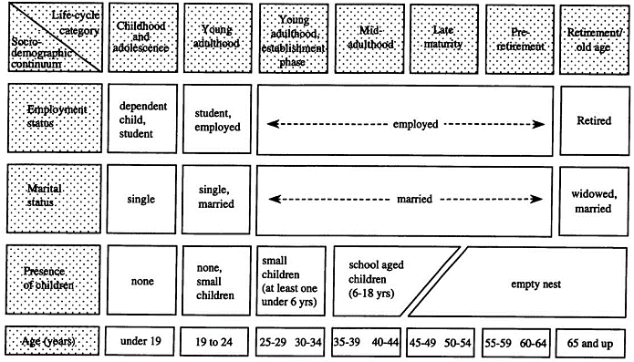

Figure I. Conceptualisation of life cycle categories (Zuzanek & Smale, 2002, p. 132)

To sum, life cycle effects are expected to be of great interest when examining changes in leisure time over the life course. Young adults are expected to experience a significantly large amount of leisure time as they get to leaving school age in comparison to the rest of the life cycle. This may be associated with a sharp decline in leisure time as the individual moves of out the domestic home and into employment. This study hypothesises that leisure time in the life course will begin to increase again as alternative factors such as employment and family stabilisation become relevant. I suggest that the beginning of this change in direction is primarily motivated by the child, as they get older, more independent, and move out of the family home. The increase in leisure time may then be extended by retirement, in which it is estimated to pertain to the highest amount of leisure time experience throughout the life course. After this peak, this influence of widowhood or even physical or mental degeneration may severely restrict an individual’s ability to engage in leisure. Overall, leisure is expected to behave as a negative, positive, negative cubic polynomial throughout the life course, with largest difference being the positive as it involves a composite of factors which facilitate and ease leisure accessibility.

## **3.5 Cohort Effects**

First and foremost, when discussing cohort effects, it is important to consider exactly what is meant by the term in this paper. Typically, a cohort is a group of people who share a characteristic, of which I shall consider age as the defining attribute. This notion, primarily referred to in the social and behavioural sciences at ‘birth cohort’ identifies groups of people based on date of birth grouping, ranging from 5-year to over 20-year categories which indicate common social events and expectations, such as entering the workforce, family formation, and retirement (Elder Jr. & George, 2016). Additionally, members of a cohort all share the same characteristic of being born, growing up, and living in the same time range. Thus, examining cohort effects over time permits also for the examination of historical and social change, a notion pioneered by Norman Ryder; ‘The new cohorts provide the opportunity for social change to occur. They do not cause change; they permit it. If change does occur, it differentiates cohorts from one another, and the comparison of their career becomes a way to study change’ (1965, p. 844). The additional conceptual distinction between cohort and generation is also to considered here to avoid unambiguity. The divide between definitions of cohort and generation is primarily the factor of being born on or around the same year. Traditional generational definitions tend to exclude this factor, instead including individuals of a much wider demographic. Mannheim’s definition of generation is perhaps more closely defined in terms of birth cohort, suggesting that ‘generations in actuality’ can be created through the similarity of birth years in addition to the formation of a ‘distinctive group consciousness’ (Mannheim, 1952). According to Mannheim, this consciousness is formed only when specific criteria are met: (1) A key historical event must occur, (2) the cohorts at-risk of becoming a generation in actuality will be young, and (3) the historical event is sufficiently disruptive as to shape the lives of adolescents and young adults (Mannheim, 1952; Elder Jr. & George, 2016). Birth cohorts and generations also have the potential to adopt certain social mechanisms; for example, influencing future cohorts in the ‘freezing’ of social consequences which emerge after a certain amount of time, described by Mannheim as *Gleichzeitigkeit des Ungleichzeitigen* (Mannheim, 1952), as well as both the ‘means of social reproduction in the sense of maintenance and stability and as a mechanism of change’ can be perpetuated by the transition of individuals through organisations and institutions (Mayer, 2015, p. 140).

When looking at German generations, it is very difficult to define groups of individuals who share the three criteria which Mannheim (1952) presents. Consequently, the definition of generation shall be limited to that which has been previously discussed – birth cohorts (specifically in 10-year intervals). Examining the development of German time-use towards leisure in conjunction with the social and technological developments opens up further gateways of understanding differences between birth cohorts. Ulrich Reinhardt (2016) provides a detailed account of time-use patterns in Germany since the 1950’s of which this study will build upon in it is analysis of cohort effects.

During the 1950’s, work as a functional role in the recovering, post-war state of Germany was a top priority to perpetuate the promising economic growth in the Federal Republic of Germany (FRG). Industrial production doubled between 1950 and 1957 and the FRG became the most economically prosperous country in Europe at the time due to several reasons. The replacement of the Reichsmark with the Deutsche Mark in 1948 commenced a huge change in the economic production in Germany; inflation was halted, taxes cut, GNP increased by around 10% each year, reparations from the United States totalled to $1.4 billion, and Germany opened itself up to the global market. Additional features include the transition away from the Nazi shadow cast over Germany, as well as the average of 6 days per week of work (48 hours). As a consequence, leisure engagement was consumed heavily when people had the time, spending quality time with family was the focus of 1950’s leisure time, with entertaining children as the most popular leisure pursuit. Reinhardt (2016) also mentions how, strangely, staring out the window was the third most common form of leisure activity in Germany.

During the 1960’s, consumption in the FRG quickly grew. Workers now had incredible purchasing power, establishing itself as a social-market economy and a step away from previous Marxist ideologies towards more capitalist-orientated ideas. The FRG became one of the first countries to consume televisions, washing machines, dishwashers, vacuum cleaners, and cars on a grand scale. The 60’s was a time for reform in the FRG. The influx of these technologies opened up the time to extend leisure pursuits into the socio-cultural domain. The 1960’s is the only period of time where cultural pursuits were ranked in the top ten; an increasing number of people were attending theatres, museums, art galleries. Television was also just beginning its debut; instead of staring out of the window, people began to spend their time staring at a box, unaware of its prevalence and importance to leisure time in the future.

The 1970’s became to be considered as the ‘golden decade of leisure time’ in the FRG. The development of the leisure industry proliferated in the 70’s, as tourism and entertainment industries set to capitalise on the increasing population, with a growing income, and a growing amount of leisure time. The FRG adopted the social significance of leisure as enjoyment and relaxation, with increasing accessibility to leisure pursuits e.g. appearance of amusement parks. Despite this, the second half of the 1970’s in the FRG introduced some extensive barriers and restrictions to leisure engagement. A worldwide economic crisis which heavily influenced the FRG became characterised by high levels of unemployment, increasing oil prices, and failing industries such as in the Ruhr. This did not appear to heavily influence leisure time in the FRG, but rather changed the ways in which individuals consumed leisure.

The 1980’s prolonged the leisure boom from that of the previous decade, albeit leisure pursuits were changing. Instead of focusing on active consumption, Germans began to consume more passively with the increasing popularity of music and television. The year 1984 brought with it the establishment of private television channels unlocking a whole world of domestic leisure entertainment opportunities, as well as the Computer Chaos Club publishing it’s first article regarding the widespread accessibility to computers and the internet on a domestic scale (1984). The ways in which people were pursuing leisure were constantly shifting as passive leisure consumption such as watching television become progressively popular. Despite this, the 1980’s also saw the first time that sport was included in the top ten leisure activities in the FRG. Reinhardt (2016) suggests that this is due to the Grand Slam victories of Boris Becker and Steffi Graf throughout the 1980’s, enticing many more Germans to get involved in sports.

The 1990’s saw an important development in regard to communications. The production of mobile telephones created a number of ways in which people could stay in touch and connect with each other, transforming it away from a means of information transfer and towards a more socially interactive form of leisure. Another important feature is the introduction of the first internet-linked GUI-based messaging software such as AOL Instant Messenger, PowWow, and ICQ. These clients replaced previous clients such as the Compatible Time-Sharing System or CompuServe's CB Simulator which were of limited availability and difficult to use. The rapid sense of communication through technology was also changing how individuals engage with leisure.

The 2000’s brought with it an emphasis on technological development at a rapid scale. Technological innovations such as smartphones, computers, internet, and the rise of the ‘smart society’ have worked their way into the very forefront of German society. The transition of leisure takes in to account changing social factors which heavily influences time-use.

Leading to present day, the decade of the 2010’s maintains the technological progression from previous decades. New devices with new features are being constructed, from artificial intelligence and virtual assistants (e.g. Google Assistant, Amazon Alexa) to augmented and virtual reality (e.g. Microsoft HoloLens, Google Glass Enterprise Edition, HTV Vive, Oculus Rift). These are still relatively new, expensive, and not very widely available forms of engaging in leisure, however it may be the case looking forward that they gain as much momentum and traction in the consumer as smartphones and personal computers. As it stands currently, television is still by far the most predominant form of leisure activity regardless of differing demographic groups. This is followed by more traditional media such as reading the newspaper or listening to the radio, and social activities such as spending time with friends and family. Behind this however, phone and internet use has consistently been growing, and perhaps will overtake television as the popularity of streaming video-on-demand services rises. The issue of technology also raises the important consideration between media competency between cohorts, as older cohorts may begin to get left behind in a technological world due to numerous barriers and restrictions; ‘lack of instructions and guidance, lack of knowledge and confidence, health-related barriers, cost, too much and too complex technology, feelings of inadequacy…lack of social interaction and communication… and scepticism about using tablets and technology in general.’ (Vaportzis, et al., 2017, p. 1687)

Overall, birth cohort effects in this study are founded upon the progression of leisure over each decade, however, the between cohort effects are hypothesised to not be of a significant magnitude as the changes in leisure are primarily the type of activity as opposed to the amount of time engaged. In consideration to Ryder’s (1965) notion of cohorts as a mechanism for social change, this may not be so apparent in an analysis of leisure time where socio-contextual factors become more applicable. Finally, I have excluded descriptions of pre-1950 birth cohorts in this section due to a lack of literature and research, as studies in Western European countries only began to emerge in the 1950’s onwards when the aspect of leisure became increasingly examined due to scientific and social awareness (Dumazedier, 1962). The following empirical analysis intends to find an answer to the proposed hypotheses on leisure time, substantiated by the theoretical framework provided.

# **4. Research Methodology**

## **4.1 Data and Sample**

The data used in this study comes from the German Socio-Economic Panel Study (SOEP, 2017) as it provides a wealth of information on German individuals and households. The study consists of annual interviews since it’s commencement in 1984 of around 30,000 individuals living in Germany. The SOEP data is one of the few, if not the only German panel surveys suited to answer the questions of this research paper as it addresses topics of daily time-use over time. Additionally, observations regarding leisure time have been included in the interviews annually, with the exception of 1990 due to a strong focus on working time, thus questions dealing with leisure time were removed for one survey year to reduce overall survey time for the respondents. The SOEP study additionally holds its own merit as one of the longest running panel studies not only in Germany, but also in the world.

The target sample for the analysis involved the selection of both males and females over the age of 16, as adult interviews in the survey started when respondents reached the age of 17. Similarly, respondents age 100 or over were removed from the sample due to an insufficient cohort size (*N* = 11), nonetheless, the resulting sample included a substantial number of cohorts. Immigrants were also excluded from the sample selection, founded upon the notion that lifestyle and cultural differences of first, second, and third generation immigrants may not necessarily be representative of the German population, thus inclusion may result in a convolution of the results (Constant & Massey, 2003). The total number of observations with immigrant backgrounds excluded in the target sample amounted to 26,640. Likewise, respondents who were living in East Germany in 1989 were excluded as with above (*N* = 22,082), lifestyle and social differences in time expenditure are unrepresentative of the population of Germany due to the political split of ownership which divided the *Bundesrepublik Deutschland* and the *Deutsche Demokratische Republik*. For the same reason, selective samples and re-samples in the SOEP which focused solely on migrant and East German populations were also discounted (*N* = 25,526). Finally, individuals with missing observations have been omitted from the analysis. After sample selection, the target sample is at 50% of the original SOEP survey sample, a fairly large proportion, however this is primarily down to the exclusion of East Germans, immigrants, and their respective replacement samples. The overall omission of these observations accounted for 50.3% of the total sample loss (*N* = 42,564). Despite this, the analysis still involves a substantially large sample size (*N* = 41,998) over a large number of person-years (*N* = 308,466). The average duration of observation for the target sample was 7.3 years per individual, with the response variable observed over an observation period of 32 years. The final sample consisted of both male and female individuals born in West Germany or the Federal Republic of Germany between the ages of 17-99 upon panel entry with no migration background.

## **4.2 Measurements**

### **4.2.1 Outcome Measure**

The outcome variable leisure time is measured based on respondent’s own consideration of their leisure time. The respondent was asked the question: “What is a typical weekday like for you? How many hours per normal workday do you spend on…leisure activities and hobbies?” The interview also considered time spent on physical activities such as sports, fitness, and gymnastics, however, due to conceptual issues relation to the problem of relativism, it is highly arguable whether these physical activities constituted towards leisure time (Dunning & Rojek, 2016). Daily leisure time above 16 hours per day was recoded to missing due to improbability and unreliability.

Measures of time use in hours transpires to be extremely useful in the analysis as it permits ease of interpretation and accuracy to a greater extent than with time categories. Time limitations due to the already vast array of questions asked in addition to the large size of the sample rendered alternative methods for measure time use such as time diaries, experiential sampling methods, and observational approaches unattainable. Stylized measures of time use have shown to be extremely valuable in exhibiting patterns across time in individuals and groups, despite sometimes resulting in exacerbated perceptions of time-use (Ver Ploeg, Michele; National Research Council (U.S.) Committee on National Statistics, 2000; Kan & Pudney, 2008).

### **4.2.2 Comparison Measure**

As an addition to an analysis of leisure time, this study shall also aim to examine whether the gradual decrease of average working hours in Germany to one of the lowest in the OECD18 has caused any implications for leisure time which may be reflected in the results. The analysis shall address average actual daily working hours based on a 5-day working week. An option to select contracted working hours was also available, however due to the inconsistency and variation between contracted working hours and actual working hours it was deemed more suitable to base estimation upon the latter. Weekly working hours greater than 70 were dropped as improbable responses.

## **4.3 Model**

The method of analysis to be utilised in this study to estimate effects of leisure time over age and between cohorts will consist of hierarchical linear modelling. The advantages of this is that it considers the nested status of individual within cohorts which would otherwise violate the independence assumption of ordinary least squares (OLS) regression. Due to this, results can be analysed in terms of within- and between-persons in order to understand how leisure time may vary over an individual’s life, and also between individuals in different cohorts. Put differently, latent growth curve modelling permits the estimation of inter-individual variability in intra-individual patterns of change over time (Browne & du Toit, 1991; Curran & Bollen, 2006; Preacher, et al., 2008; McArdle, 2009). Additionally, the use of hierarchical linear modelling makes it possible to include variables in terms of polynomial functions when compared to traditional OLS regression.

Specifically, I shall employ the random effects model to tackle the issue of nested individuals. The random effects model holds the assumption that the independent variables in the model are uncorrelated with individual-specific effects. As this is expected to be a foundation behind the primary method of data analysis in this paper due to the nature of age-cohort analysis, random effects models should outperform the fixed effects model. The fixed effects model fails to account for the variability of effects across individuals and assumes that independent variables in the model *are* correlated with individual-specific effects, thus it may not be suitable for this analysis. A comparison of consistency between the fixed and random effects models is to be performed using the Durbin–Wu–Hausman test (Hausman, 1978) to test for endogeneity and model selection if necessary. Additional postestimation tests to consider for this analysis are the Breusch-Pagan Lagrange multiplier test (Breusch & Pagan, 1980) for random-effects against regular OLS regression to address issues of homoskedasticity, and recovering individual-specific effects using predicted error components. The random effects model is shown below, where identifies between-entity error and identifies within-entity error.

Furthermore, the prediction of age and cohort effects on leisure time is often confounded by the linear correlation of age, cohort, and period (period = age + cohort) (Leopold, et al., 2018), thus the inclusion of these collinear predictors into the model will result in the inability to make a distinction between each of these effects. This is overcome in this analysis through the omission of the survey year from the estimation model. Explicitly, it is implied that period effects are to be constrained to zero as there are no foreseeable events which occurred during the survey period which impacted upon the leisure time of all age groups. The period effect is identified as an event occurring at the calendar date at which the response variable was measured, which may have an influence on the response variable. This is highlighted by Suzuki (2012) in a popular fictional dialogue between a senior worker (A) and a junior worker (B):

A: I can’t seem to shake off this tired feeling. Guess I’m just getting old. [Age effect]

B: Do you think it’s stress? Business is down this year, and you’ve let your fatigue build up. [Period effect]

A: Maybe. What about you?

B: Actually, I’m exhausted too! My body feels really heavy.

A: You’re kidding. You’re still young. I could work all day long when I was your age.

B: Oh, really?

A: Yeah, young people these days are quick to whine. We were not like that. [Cohort effect]

There are other ways in which hierarchical linear models can be estimated, yet hierarchical linear modelling appeals its merit as the most efficient method. Aggregating the data into their respective means and fitting a regression runs the risk of exhibiting Simpson’s Paradox, where the regression of the means results in a negative trend when the clusters actually result in a positive trend (Simpson, 1951). Running OLS regression for each group is also another possibility, yet this would result in smaller sample sizes in the regression model, underpowering the results and disregarding supplementary samples of which hierarchical linear modelling uses to inform the inferences of what may be occurring in specific groups. I shall overcome the ongoing issue of significance levels in estimation results by highlighting three possible significance groups (*p < 0.05, p < 0.01, p < 0.001*), but utilising only the strictest p-value specification in my analysis of results as a p-value near 0.05 only offers weak evidence against the null hypothesis and has been highly contested by others (Rice, 1989; Goodman, 1999; Wasserstein & Lazar, 2016). The age-cohort framework will compliment this analysis by testing for and separating patterns over the life-course, and patterns between cohorts.

As discussed in the literature, the use of interaction and polynomial terms shall be employed in order to provide a more in-depth understanding of within-groups and greater accuracy of estimation. A descriptive analysis of leisure time across the life cycle is characterised by a cubic term, whereas working hours implies a quadratic term (Appendix 1). As previously stated, it is anticipated that both the relationship between leisure time and working hours on age is non-linear due to life-cycle effects. Descriptive statistics are shown in Table 1. From the whole sample, an average of 2.1 hours per weekday are spent engaging in leisure activities. The average age of the sample is 48 and men and women are fairly equally included – there is not likely to be any gender bias. The average daily working hours is considerably low at 4.3 hours per day, however when considering the part-time workers, the unemployed, and the marginally unemployed, this appears accurate. In my analysis I intend to provide a concrete and comprehensive method of estimating leisure time on both the intra- and the inter-individual levels. Finally, in order to address the question of whether a decrease in working hours reflects a symmetrical increase in leisure I shall compare models of both factors.

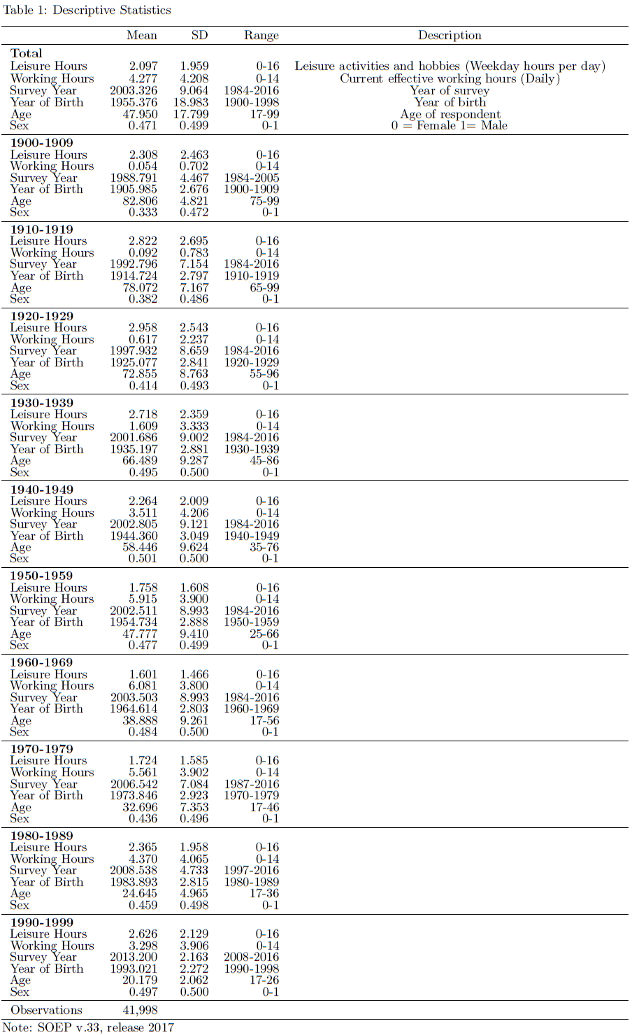

# **5. Results**

The main results shown in Tables 2 and 3 support our hypothesis on the trajectory of leisure time over the life course. The model supports the change of leisure time over age in line with life course events such as entering employment, getting married and having children, and retirement. The model, shown for each males and females explains a proportion of variance in the model (*Male R² = 0.106, Female R² = 0.094*). Additionally, the hypothetical cubic pattern of leisure time over the life course is supported by the pattern of the coefficients, however, the linear slope at the cubic term of age is neither negative or positive, but at a constant (*β = 0.000, p < 0.001*). This demonstrates a substantial threshold which the elderly reach in leisure time of around 3.2 hours per weekday at the age of 80+. The most substantial change in leisure time occurs over the earliest period of a person’s life; between the ages of 17 to 30, average leisure time is estimated to fall by around half an hour every five years. Considering that the average number of leisure hours at the age of 17 is 2.8 hours per day, this does not leave much room for the remaining leisure time (Appendix 2). Additionally, intra-cohort differences have substantially decreased over time, almost to a point where an intra-cohort difference is absent. The intra-cohort difference in leisure hours between the 1900 and 1910 birth cohorts is predicted to have decreased by around three times when compared with the 1980 and 1990 birth cohorts.

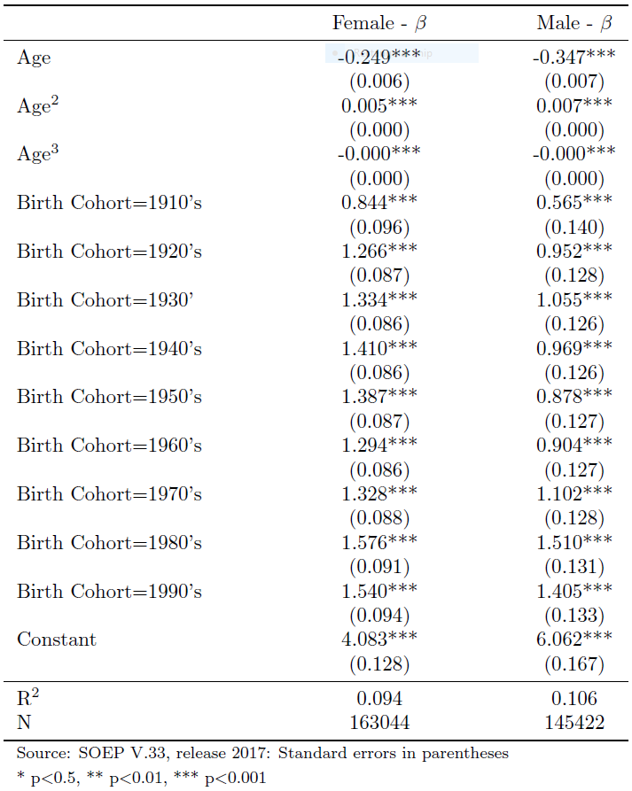

Table 2: Model 1 – Leisure Time

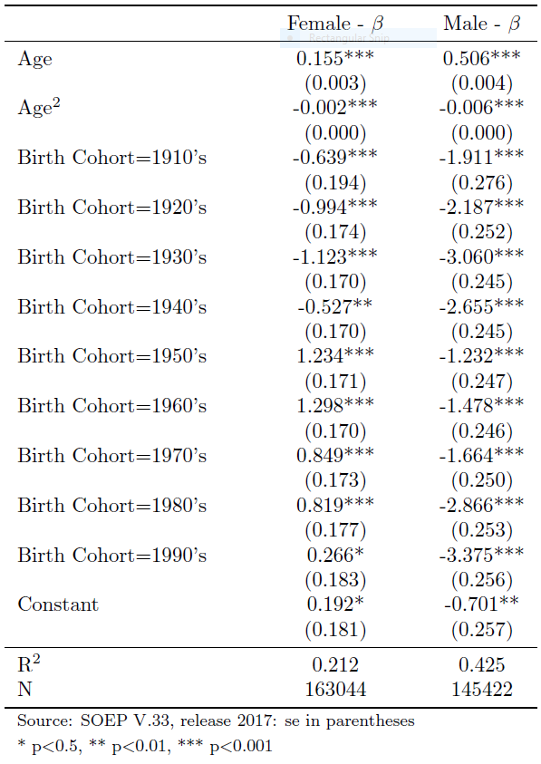

Table 3: Model 2 – Working hours

All variables in Model 1 remain significant. Additionally, there does not appear to be a large difference between male and female average leisure time each weekday, rather males are estimated to surpass females in leisure time by an average of only 2 and a half minutes per day over the life course. What may be interesting here is the nature of comparison between men and women over the life course. Although on average there does not appear to be much of a difference between male and female leisure time, hierarchical linear modelling permits a closer examination of the age and cohort effects (Figure 2).

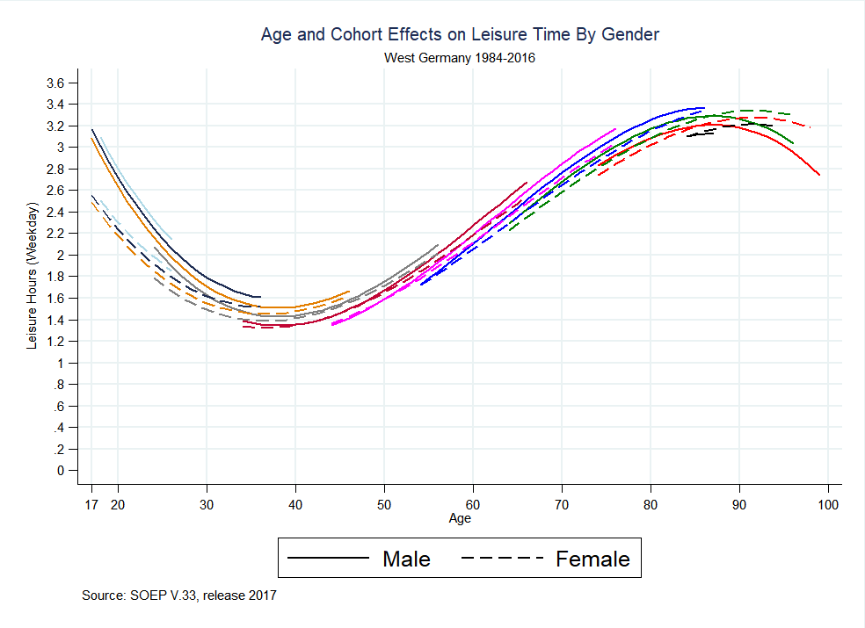

Figure 1: Age & Cohort Effects of Leisure Time by Gender

Figure 2 defines some interesting characteristics of leisure time over the life course. In the earlier stages of life, males tend to engage more in leisure time than females up until the age of 25 when gender differences become congruent. Average leisure time expenditure remains substantially similar between men and women up until the age of 90 where male leisure time falls but female leisure time remains fairly stable.

With regards to the hypothesis on whether working hours has decreased over time symmetrically to leisure time, the data does not support this. Figure 3 displays the relationship between cohorts over time of predicted leisure time and working hours. Cohort differences in working hours are larger in the 1970’s and 1980’s cohorts in comparison to their counterparts. The symmetry between working time and leisure time over the life course is obvious. This effect is replicated when analysing leisure and working hours with respect to gender, despite women on average engaging in less working hours compared to men (Appendix 3). Paradoxically, as women are working less hours than men then it may be expected that they have a greater opportunity to engage in leisure time. This does not seem consistent with the results however, as on average there is no distinction between male and female leisure time which suggest that women may be committing their time to other activities such as domestic activities. The data also supports the popular notion that more women are entering the workforce and with a greater number of working hours than that of previous women in full-time work. The results of the analyses have presented an insightful look into how the German population engage in leisure time and the differences between cohorts and demographics, as well as over the life course. Whether or not a hypothesis has been validated or refuted by the results, valuable information examining the changes, or lack thereof, has been produced, widening the current insight on leisure behaviour in Germany.

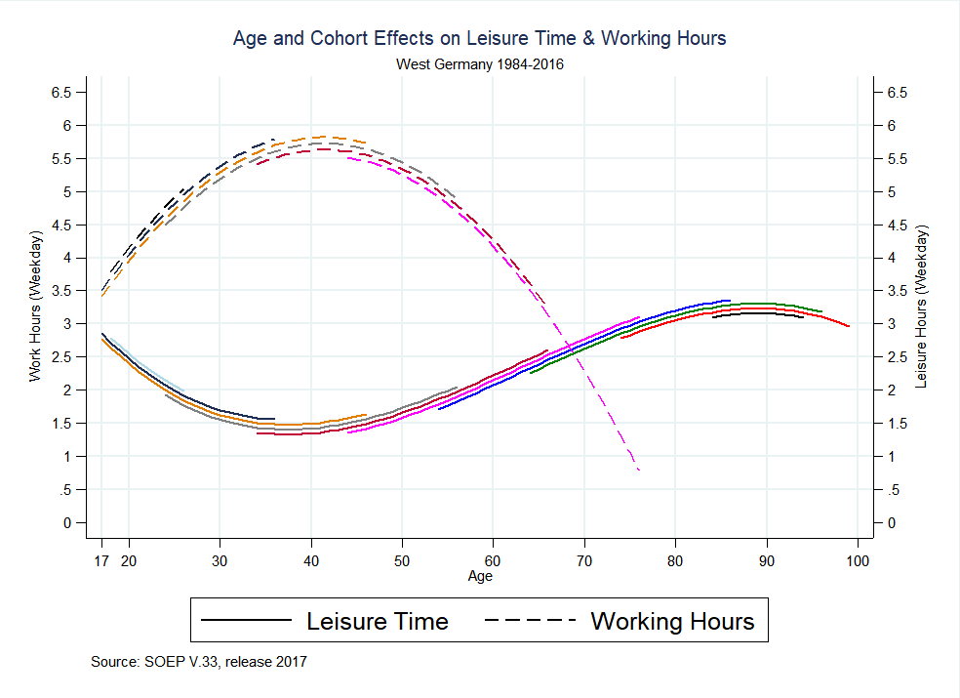

Figure 3: Age & Cohort Effects of Leisure Time and Working Hours

# **6. Discussion**

## **6.1 Limitations of the Study**

It is also necessary to discuss some of the weaknesses of this research paper with the prospect of overcoming these in the future. First, it may be of additional value to conduct a cross-national longitudinal analysis of leisure time. By doing so it would be possible to examine the effects of life cycle and cohort over time through a variety of different countries, and a comparison of Germany against other countries may prove to be very useful. The problem faced here is associated with the lack of suitable data. Although longitudinal panel surveys have been conducted before in a variety of countries, none are quite similar to the scale and size of the SOEP study (2017). Additionally, very few longitudinal surveys contain variables regarding time-use, of which is vital in answering my research question. For the time being, a detailed cross-national examination of age and cohort effects on leisure time is beyond the scope of this analysis.

Second, the measurement of the outcome variable in hours per day may appear to understate the changes and differences in leisure time. By analysing average hours per weekday spent on leisure time, the results are scaled down to a certain degree and thus would not have the same psychological impact as, for example, leisure hours per year. In lieu of this it may be more feasible to use the measurement of leisure hours per week. This could be easily computed from the outcome variable used in this analysis. In any case, the measurement utilised in this study is sufficiently motivated by the detailed account of daily time use which it incurred. Overall, the strengths of the use of the SOEP data (2017) in its size and value overcomes most of the weaknesses associated with this type of research, and the limitations presented above do not impact the validity of this study in any substantial way.

## **6.2 Conclusion**

In this paper, I examined the effects of life course and cohort effects on the amount of time individuals spend dedicated to leisure each day. I utilised hierarchical linear modelling while controlling for individuals nested within time periods and including the relevant controls (*N* = 41,998). The results displayed negative, positive, and a constant pattern of leisure time throughout the life course, decreasing rapidly between the ages of 17 and 40, increasing again from the ages of 40 to 80, finally stabilising it its crest between the ages of 80 and 100. Cohort differences are minimal, yet the inter-cohort difference is smaller in more recent cohorts. Gender differences overall were almost non-existent, yet females were predicted to experience less leisure time until the age of 25, and more leisure above the age of 90, in comparison to males. Between the ages of 25 and 90, gender differences are negligible. Overall, the model produces interesting findings which can be further developed to gain a greater insight into individuals time-use. Hierarchical linear modelling assisted this process with the consideration of the nested structure of the data in the estimation of model parameters, producing greater accuracy and reliability.

The hypotheses of this research paper have also been addressed in the empirical research by addressing differences between groups and within groups. As there are a multitude of influences involved here it may be useful to analyse them individually:

First, the hypothesis of those working more hours engaging in a greater amount of leisure time than their counterparts has been proved false, the subtle transformation of Veblen’s (1899) theory on leisure consumption into contemporary Germany does not hold any legitimacy. The opposite is true in fact, those with the least working hours experience the greatest amount of leisure time. Thus, the data does not seem consistent with the notion that full-time work facilitates the engagement with leisure time due to the additional resources that are associated with full-time work (e.g. social contacts, wealth). The data suggests that the unemployed maintain the greatest accessibility to leisure engagement, perhaps primarily for the reason that the unemployed have greater access to a lot more time in general. The requirements of full-time work to fit alternative daily activities around the occupational schedule limits the amount of acceptable time-use as leisure, even further so considering the work-leisure fusion. This is perhaps the most parsimonious explanation, despite the existence of additional confounding layers which are encouraged to be explored in future research

Second, the hypothesised life course effects of employment status, marital status, and parental status complement the pattern of leisure time throughout the life course, as the trough, crests, and slope of the curve appear in congruence with changes in leisure time. The entry into the employment market materialises in the form of a substantial decrease in leisure time, catalysed by marital and parental factors which are soon to follow. In midlife, individuals show signs of beginning to be able to balance work and leisure more effectively. Complimentary to this, it is also the period where children start to develop independence and often move away to university or move out of the family home, opening up a gap in time that there may not have been before with the presence of the child. With this gap in time appearing at this stage of life in combination with the decline in working hours at the same stage in life, people are having more time to assign to leisure than in the infancy of their career-building. The stage during and leading up to retirement represents a substantial increase in leisure time, alluding to the discretionary balance between work and leisure as a primary factor and the competitive nature of the two. Finally, in post-retirement and old age, the hypothesis was not legitimated by the data. I projected a decrease in leisure time at a certain threshold for several reasons. First, the elderly population are much more prone to physical degeneration thus restricting their ability to engage in leisure activities, and second, mental degeneration in the elderly population is also not uncommon, resulting in the same consequence as physical degeneration with the added problem of the respondent may not even be aware that they are engaging in leisure time. This was not the case however, and the data points towards the elderly as maintaining the highest and most stable amount of leisure time in contrast to those in young adulthood, midlife, and retirement age. This is somewhat surprising, yet it is possible that the assumptions regarding the physical and mental degeneration of the elderly may be overestimated. Physical degeneration does not necessarily limit or restrict accessibility to leisure time, more so to certain types of leisure activities. Hence this emphasises and insinuates the constantly changing nature of leisure as individuals can dedicate time they once spent on a leisure activity they are unable to do anymore onto another leisure activity which they are able engage in.

Third, I hypothesised minimal or negligible cohort effects on leisure time based on the literature, signifying that the main cohort effects on leisure are towards the type of activity rather than the time spent on leisure. Leisure time has remained somewhat consistent over cohorts, with a gradual, perhaps even asymptotic-style decrease in inter-cohort differences. The data supported this hypothesis, showing only slight cohort differences, and within-cohort patterns of leisure time were similar across all cohorts.

Fourth, the hypothesised relationship between the decrease in work hours and the increase in leisure hours over time presented interesting findings. Instead of the negation of one by the other, I found the opposite effect, namely that leisure time is increasing over time for both males and females whilst working hours for men is only slightly decreasing and working hours for women are increasing, overall appearing somewhat counterintuitive. The hypothesised symmetry is non-existent. Rather, an alternative explanation for this phenomenon may motivated by the fusion between work and leisure. With an increasing technological competence amongst adults and young adults, it is only a matter of time before work, leisure, and technology become almost indistinguishable. The rise in leisure time can therefore be accredited here to the use of technology within the workplace, which may simulate the experience of leisure (e.g. watching videos on a smartphone during the working day). Furthermore, as an increasing number of women enter the workforce, this must also be compensated (in the case of parents) by the complementary parent’s concession to working hours in order to care for the child. This role has been opening up more and more to men, balancing the scales to a certain extent. Nonetheless, the decline of males in work is not proportionate to the increase of women in work, resulting in a greater number of total individuals working.

Revisiting the opening words of this research paper, my results indicate that average working hours has increased, but so have average leisure hours. The difference result between men and women on leisure time here is also surprising, largely because I expected it not to be so unsubstantial. Additionally, and perhaps intuitively, I also found that a greater number of working hours meant less time to spend on leisure. Rather, those who work the least amount have a greater opportunity to experience leisure time despite alternative burdens such as committing time to domestic housework and financial limitations. To conclude, those who ‘work hard’ don’t get the time to ‘play hard’, but overall, they are working harder, and playing harder than ever before.

# **References**

Aguiar, M. & Hurst, E., 2006. *Measuring Trends in Leisure: The Allocation of Time Over Five Decades.* the National Bureau of Economic Research Working Paper 12082 ed. Cambridge, MA: the National Bureau of Economic Research.

Arai, S. M., Griffin, J., Miatello, A. & Greig, C. L., 2008. Leisure and Recreation Involvement in the Context of Healing from Trauma. *Therapeutic Recreation Journal Special Issue,* 42(1), pp. 37-55.

Barrick, M. R., Thurgood, G. R., Smith, T. A. & Courtright, S. H., 2014. Collective Organizational Engagement: Linking Motivational Antecedents, Strategic Implementation, and Firm Performance. *Academy of Management Journal,* 58(1), pp. 111-135.

Bell, A. L. & Freeman, R. B., 2001. The incentive for working hard: explaining hours worked differences in the US and Germany. *Labour Economics,* 8(2), pp. 181-202.

Bialeschki, D. M. & Henderson, K., 2006. Leisure in the Common World of Women. *Leisure Studies,* 5(3), pp. 299-308.

Bittman, M. & Wajcman, J., 2000. The Rush Hour: The Character of Leisure Time and Gender Equity. *Social Forces,* 79(1), pp. 165-189.

Boissevain, C., 2017. Smart City Lighting. In: S. McClellan, J. Jimenez & G. Koutitas, eds. *Smart Cities.* Cham: Springer, pp. 181-195.

Breusch, T. S. & Pagan, A. R., 1980. The Lagrange Multiplier Test and its Applications to Model Specification in Econometrics. *The Review of Economic Studies,* 47(1), pp. 239-253.

Browne, M. W. & du Toit, S. H. C., 1991. Models for learning data. In: L. M. Collins & J. L. Horn, eds. *Best methods for the analysis of change: Recent advances, unanswered questions, future directions..* Washington DC: American Psychological Association, pp. 47-68.

Bundesministerium für Familie, Senioren, Frauen und Jugend, 2017. *Volunteering in Germany: Key Findings of the Fourth German Survey on Volunteering,* Berlin: Bundesministerium für Familie, Senioren, Frauen und Jugend.

Burda, M., Hamermesh, D. S. & Weil, P., 2013. Total Work, Gender and Social Norms. *Journal of Population Economics,* 26(2), pp. 507-530.

Caldwell, L. L., Smith, E. A. & Weissinger, E., 2013. The Relationship of Leisure Activities and Perceived Health of College Students. *Society and Leisure,* 15(2), pp. 545-556.

Cameron, K., Mora, C., Leutscher, T. & Calarco, M., 2011. Effects of Positive Practices on Organizational Effectiveness. *The Journal of Applied Behavioural Science,* 47(3), pp. 266-308.

Campbell, A., 1981. *The Sense of Well-Being in America: Recent Patterns and Trends.* New York: McGraw-Hill.

Centers for Disease Control & Prevention, 2005. Trends in Leisure-Time Physical Inactivity by Age, Sex, and Race/Ethnicity — United States, 1994–2004. *Morbidity and Mortality Weekly Report,* 54(39), pp. 991-994.

Chaos Computer Club, 1984. The Chaos Computer Club introduces itself. *Die Datenschleuder,* Issue 1.

Chia-Yuan, Y., 2017. Racial/Ethnic and Income Differences in Obesity Among Older Adults: The Role of Leisure-time Physical Activity and Neighborhood Social Cohesion. *Journal of Physical Activity and Health,* 14(3), pp. 169-175.

Chopra, M., Galbraith, S. & Darnton-Hill, I., 2002. A global response to a global problem: The epidemic of overnutrition. *Bulletin of the World Health Organization,* 80(12), pp. 952-958.

Christian, B. J., 2011. Targeting the Obesity Epidemic in Children and Adolescents: Research Evidence for Practice. *Journal of Pediatric Nursing,* 26(5), pp. 503-506.

Christian, M. S., Garza, A. S. & Slaughter, J. E., 2011. Work engagement: A quantitative review and test of its relations with task and contextual performance. *Personnel Psychology,* 64(1), pp. 89-136.

Clout, H. D., 2017. Regional Development in Western Europe. In: H. D. Clout, ed. *Routledge Revivals: Regional Development in Western Europe (1975).* London: Routledge.

Coleman, D. & Iso-Ahola, S. E., 1993. Leisure and Health: The Role of Social Support and Self-Determination. *Journal of Leisure Research,* 25(2), pp. 111-128.

Constant, A. & Massey, D. S., 2003. Self-selection, earnings, and out-migration: A longitudinal study of immigrants to Germany. *Journal of Population Economics,* 16(4), pp. 631-653.

Cummings, J., 1899. The Theory of the Leisure Class. *The Journal of Political Economy,* 7(4), pp. 425-455.

Curran, P. J. & Bollen, K. A., 2006. *Latent Curve Models: A Structural Equation Perspective.* Illustrated ed. s.l.:John Wiley & Sons.

Dietz, W. H., 2004. Overweight in childhood and adolescence. *New England Journal of Medicine,* 350(9), pp. 855-857.

Duerden, M. D., Courtright, S. H. & Widmer, M. A., 2017. Why People Play at Work: A Theoretical Examination of Leisure-at-Work. *Leisure Sciences,* pp. 1-15.

Dumazedier, J., 1962. Vers une civilisation du loisir?. *Les Études philosophiques,* 17(4), pp. 538-538.

Dunning, E. & Rojek, C., 2016. *Sport and Leisure in the Civilizing Process: Critique and Counter-Critique.* Illustrated ed. s.l.:Springer.

Elder Jr., G. H. & George, L. K., 2016. Age, Cohorts, and the Life Course. In: M. J. Shanahan, J. T. Mortimer & M. K. Johnson, eds. *Handbook of the Life Course. Handbooks of Sociology and Social Research.* Cham: Springer, pp. 59-85.

Ellis, G. & Witt, P. A., 1984. The Measurement of Perceived Freedom in Leisure. *Journal of Leisure Reasearch,* 16(2), pp. 110-123.

Gajadhar, B. J., De Kort, Y. A. W., IJsselsteijn, W. A. & Poels, K., 2009. *Where everybody knows your game: the appeal and function of game cafés in western Europe.* Athens, ACM, pp. 28-35.

Godbey, G. & Parker, S., 1976. *Leisure Studies and Services: An Overview.* Philadelphia: Saunders.

Goodman, S. N., 1999. Toward Evidence-Based Medical Statistics. 1: The P Value Fallacy. *Annals of Internal Medicine,* 130(12), pp. 995-1004.

Griffin, J., 2005. Recreation Therapy for Adult Survivors of Childhood Abuse: Challenges to Professional Perspectives and the Evolution of a Leisure Education Group. *Therapeutic Recreation Journal,* 39(3), pp. 207-228.

Gross, D., 2009. No Rest for the Wealthy. *The New York Times*, 1 July, p. BR19.

Hassing, L. B., 2017. Gender Differences in the Association Between Leisure Activity in Adulthood and Cognitive Function in Old Age: A Prospective Longitudinal Population-Based Study. *The Journals of Gerontology,* Series B(gbx170).

Hausman, J. A., 1978. Specification Tests in Econometrics. *Econometrica,* 46(6), pp. 1251-1271.

Haylett, C., 2001. Illegitimate Subjects?: Abject Whites, Neoliberal Modernisation, and Middle-Class Multiculturalism. *Environment and Planning D: Society and Space ,* 19(3), pp. 351-370.

Hendricks, J. & Cutler, S. J., 1990. Leisure in Life-Course Perspective. In: R. Settersten, ed. *Lives in Time and Place and Invitation to the Life Course: The Problems and Promises of Developmental Science.* s.l.:Routledge.

Hiekel, N., Liefbroer, A. C. & Poortman, A.-R., 2015. Marriage and separation risks among German cohabiters: Differences between types of cohabiter. *Population Studies,* 69(2), pp. 237-251.

Holden, E., 2007. *Achieving Sustainable Mobility: Everyday and Leisure-time Travel in the EU.* 1st ed. London: Routledge.

Hubbard, P., 2017. Bohemia on the High Street. In: P. Hubbard, ed. *The Battle for the High Street.* London: Palgrave Macmillan.

Iso-Ahola, S. E., 2009. A Theory of Substitutability of Leisure Behavior. *Leisure Sciences,* 8(4), pp. 367-389.

Jonsdottir, I. H. et al., 2010. A prospective study of leisure-time physical activity and mental health in Swedish health care workers and social insurance officers. *Preventative Medicine,* 51(5), pp. 373-377.

Kabanoff, B., 1980. Work and nonwork: A review of models, methods, and findings. *Psychological Bulletin,* 88(1), pp. 60-77.

Kahneman, D. et al., 2006. Would You Be Happier If You Were Richer? A Focusing Illusion. *Science,* 312(5782), pp. 1908-1910.

Kando, T. M., 1975. *Leisure and Popular Culture in Transition.* Saint Louis: Mosby.

Kan, M. Y. & Pudney, S., 2008. Measurement Error in Stylized and Diary Data on Time Use. *Sociological Methodology,* 38(1), pp. 101-132.

Kaplan, M., 1975. *Leisure Theory and Policy.* New York: John Wiley.

Klärner, A. & Knabe, A., 2017. On the normative foundations of marriage and cohabitation: Results from group discussions in eastern and western Germany. *Demographic Research,* 36(53), pp. 1637-1666.

Kolar, V., 1993. Leisure and recreation: Experiences and limitations. *Family Matters,* Issue 34.

Koplan, J. P. et al., 2005. *Preventing childhood obesity: Health in the balance.* Washington, DC: National Academic Press.

Kuentzel, W. F. & Heberlein, T. A., 2008. Life Course Changes and Competing Leisure Interests as Obstacles to Boating Specialization. *Leisure Sciences,* 30(2), pp. 143-157.

Lansing, J. B. & Kish, L., 1957. Family Life Cycle as an Independent Variable. *American Sociological Review,* 22(5), pp. 512-519.

Leopold, T., Skopek, J. & Schulz, F., 2018. Gender Convergence in Housework Time: A Life Course and Cohort Perspective. *Sociological Science,* 5(13), pp. 281-303.

Lynd, R. S. & Lynd, H. M., 1929. *Middletown, a study in contemporary American culture.* New York: Harcourt, Brace and Company.

Lynd, R. S. & Lynd, H. M., 1937. *Middletown In Transition: A Study In Cultural Conflicts.* New York: Harcourt, Brace, and Company.

Mannheim, K., 1952. The sociological problem of generations. In: K. Mannheim, ed. *Essays on the sociology of knowledge.* London: Routledge and Kegan Paul, pp. 276-322.

Mayer, K. U., 2015. The German Life History Study - An Introduction. *European Sociological Review,* 31(2), pp. 137-143.

McArdle, J. J., 2009. Latent variable modeling of differences and changes with longitudinal data. *Annual Review of Psychology,* Volume 60, pp. 577-605.

McCormack, T., 1971. Politics and leisure. *International Journal of Comparative Sociology,* Volume 12, pp. 168-161.

Meister, T. & Pedlar, A., 2013. Leisure Patterns and Needs of Adult Survivors of Childhood Sexual Abuse. *Journal of Physical Education, Recreation & Dance ,* 63(4), pp. 52-55.

Mencken, H. L., 1919. *Prejudices: First Series.* New York: Knopf.

Merriam-Webster, n.d. *Conspicuous Consumption.* [Online]   
Available at: https://www.merriam-webster.com/dictionary/conspicuous%20consumption  
[Accessed 6 June 2018].

Meyer, J. P., Stanley, D. J., Herscovitch, L. & Topolnytsky, L., 2002. Affective, Continuance, and Normative Commitment to the Organization: A Meta-analysis of Antecedents, Correlates, and Consequences. *Journal of Vocational Behaviour,* 61(1), pp. 20-52.

Mota, J. & Esculcas, C., 2002. Leisure-time physical activity behavior: Structured and unstructured choices according to sex, age, and level of physical activity. *International Journal of Behavioural Medicine,* 9(2), pp. 111-121.

Mulkay, M., 1979. Knowledge and Utility: Implications for the Sociology of Knowledge. *Social Studies of Science,* 9(1), pp. 63-80.

OECD, 2009. Special Focus: Measuring Leisure in OECD Countries. In: *Society at a Glance 2009: OECD Social Indicators.* Paris: OECD Publishing.

OECD, 2018. *Hours worked (indicator).* [Online]   
Available at: https://data.oecd.org/emp/hours-worked.htm  
[Accessed 05 June 2018].

OECD, 2018. *Labour force participation rate.* [Online]   
Available at: https://data.oecd.org/emp/labour-force-participation-rate.htm#indicator-chart  
[Accessed 05 June 2018].

Office of the Surgeon General (US); Office of Disease Prevention and Health Promotion (US); Centers for Disease Control and Prevention (US); National Institutes of Health (US), 2001. *The Surgeon General's Call To Action To Prevent and Decrease Overweight and Obesity,* Rockville (MD): Office of the Surgeon General (US).

Parker, S., 1975. The Sociology of Leisure: Progress and Problems. *The British Journal of Sociology,* 26(1), pp. 91-101.

Payne, L. L., Mowen, A. J. & Montoro-Rodriguez, J., 2006. The Role of Leisure Style in Maintaining the Health of Older Adults with Arthritis. *Journal of Leisure Research,* 38(1), pp. 20-45.

Peck, J., 2012. Austerity Urbanism. *City,* 16(6), pp. 626-655.

Porter, L. W., Lawler, E. E. & Hackman, R. J., 1975. *Behaviour in Organisations.* New York: McGraw-Hill.

Poser, S., 2010. *Freizeit und Technik.* [Online]   
Available at: http://ieg-ego.eu/de/threads/crossroads/technisierte-lebenswelten/stefan-poser-freizeit-und-technik  
[Accessed 06 June 2018].

Preacher, K. J., Wichman, A. L., Briggs, N. E. & MacCallum, R. C., 2008. *Latent Growth Curve Modeling.* Illustrated ed. s.l.:SAGE.

Quist, J. S. et al., 2017. Effects of active commuting and leisure-time exercise on fat loss in women and men with overweight and obesity: a randomized controlled trial. *International Journal of Obesity,* 42(3), pp. 469-478.

Rapoport, R. & Rapoport, R., 1974. Four Themes in the Sociology of Leisure. *The British Journal of Sociology,* 25(2), pp. 215-229.

Rapoport, R., Rapoport, R. & Strelitz, Z., 1975. *Leisure and the family life cycle.* Oxford, England: Routledge & Kegan Paul.

Reinhardt, U., 2016. *Stiftung für Zukunftsfragen (2016): Leisure Monitor 2016,* Hamburg: British American Tobacco.

Rice, W. R., 1989. Analyzing tables of Statistical Tests. *Evolution,* 43(1), pp. 223-225.

Rovio, S. et al., 2005. Leisure-time physical activity at midlife and the risk of dementia and Alzheimer's disease. *Neurology,* 4(11), pp. 705-711.

Ryder, N. B., 1965. “The Cohort as a Concept in the Study of Social Change. *American Sociological Review,* 30(6), pp. 843-861.

Sanik, M. M., 1990. Parents' time use: A 1967–1986 comparison. *Lifestyles,* 11(3), pp. 299-316.

Sassatelli, R., 2010. *Fitness Culture: Gyms and the Commercialisation of Discipline and Fun.* Illustrated ed. s.l.:Springer.

Schooler, C. & Mulatu, M. S., 2001. The reciprocal effects of leisure time activities and intellectual functioning in older people: A longitudinal analysis.. *Psychology and Aging,* 16(3), pp. 466-482.

Searle, M. S. & Jackson, E. L., 2009. Socioeconomic variations in perceived barriers to recreation participation among would‐be participants. *Leisure Sciences,* 7(2), pp. 227-249.

Seufert, M., Moldovan, C., Burger, V. & Hobfeld, T., 2017. *Applicability and limitations of a simple WiFi hotspot model for cities.* Tokyo, 2017 13th International Conference on Network and Service Management (CNSM), pp. 1-7.

Shaw, S. M., 1985. Gender and Leisure: Inequality in the Distribution of Leisure Time. *Journal of Leisure Research,* 17(4), pp. 266-282.

Shaw, S. M., 1994. Gender, Leisure, and Constraint: Towards a Framework for the Analysis of Women's Leisure. *Journal of Leisure Research,* 26(1), pp. 8-22.

Simpson, E. H., 1951. The Interpretation of Interaction in Contingency Tables. *Journal of the Royal Statistical Society. Series B (Methodological),* 13(2), pp. 238-241.

Singh-Manoux, A., Richards, M. & Marmot, M., 2003. Leisure activities and cognitive function in middle age: evidence from the Whitehall II study. *Journal of Epidemiology and Community Health,* 57(11), pp. 907-913.

SOEP, 2017. *Socio-Economic Panel.* s.l.:s.n.

Stang, J. & Bayerl, C. T., 2003. Position of the American Dietetic Association: child and adolescent food and nutrition programs. *Journal of the American Detetic Association,* 103(7), pp. 887-893.

Statistisches Bundesamt, 2018a. *Time use Survey 2012/2013.* [Online]   
Available at: https://www.destatis.de/EN/FactsFigures/SocietyState/IncomeConsumptionLivingConditions/TimeUse/Tables/LeisuretimeActivities_Sex_ZVE.html  
[Accessed 04 June 2018].

Statistisches Bundesamt, 2018b. *Time use Survey 2012/2013.* [Online]   
Available at: https://www.destatis.de/EN/FactsFigures/SocietyState/IncomeConsumptionLivingConditions/TimeUse/Tables/TimeUse_Sex_ZVE.html  
[Accessed 05 June 2018].

Statistisches Bundesamt, 2018c. *Birth rate continued in 2016.* [Online]   
Available at: https://www.destatis.de/DE/PresseService/Presse/Pressemitteilungen/2018/03/PD18_115_122.html  
[Accessed 06 June 2018].

Statistisches Bundesamt, 2018d. *Population.* [Online]   
Available at: https://www.destatis.de/EN/FactsFigures/Indicators/LongTermSeries/Population/lrbev04.html  
[Accessed 06 June 2018].

Statistisches Bundesamt, 2018e. *Young mothers are becoming increasingly rare in the EU.* [Online]   
Available at: https://www.destatis.de/Europa/DE/Thema/BevoelkerungSoziales/Bevoelkerung/Junge_Muetter.html  
[Accessed 06 June 2018].

Stebbins, R. A., 2006. Choice and Experiential Definitions of Leisure. *Leisure Sciences,* 27(4), pp. 349-352.

Suzuki, E., 2012. Time changes, so do people. *Social Science & Medicine,* 75(3), pp. 452-456.

Trussell, D. E. & Mair, H., 2010. Seeking Judgement Free Spaces: Poverty, Leisure, and Social Inclusion. *Journal of Leisure Research,* 42(4), pp. 513-521.

UN Volunteers, 2015. *State of the World's Volunteerism Report,* Randers C, Denmark: Phoenix Design Aid.

Van Moorst, H., 1982. Leisure and Social Theory. *Leisure Studies,* 1(2), pp. 157-169.

Vaportzis, E., Clausen, M. G. & Gow, A. J., 2017. Older Adults Perceptions of Technology and Barriers to Interacting with Tablet Computers: A Focus Group Study. *Frontiers in Psychology,* Volume 8, pp. 1687-.

Veal, A. J., 2017. *Research Methods for Leisure and Tourism.* 5th ed. s.l.:Pearson UK.

Veblen, T., 1899. *The Theory of the Leisure Class.* 2nd ed. New York: B. W. Huebsch.

Veblen, T., 1973. *The Theory of the Leisure Class: With an Introduction by John Kenneth Galbraith.* s.l.:Houghton Mifflin School.

Ver Ploeg, Michele; National Research Council (U.S.) Committee on National Statistics, 2000. Survey Design Issues. In: *Time-use measurement and research : report of a workshop.* Washington, D.C.: National Academy Press, pp. 36-50.

Verbrugge, L. M., Gruber-Baldini, A. L. & Fozard, J. L., 1996. Age Differences and Age Changes in Activities: Baltimore Longitudinal Study of Aging. *The Journals of Gerontology,* 1(1), pp. 30-41.

Wang, H.-X., Xu, W. & Pei, J.-J., 2012. Leisure Activities, Cognition & Dementia. *Biochimica et Biophysica Acta (BBA) - Molecular Basis of Disease,* 1822(3), pp. 482-491.

Wasserstein, R. L. & Lazar, N., 2016. The ASA's Statement on p-Values: Context, Process, and Purpose. *The American Statistician,* 70(2), pp. 129-133.

Werneck, A. O. et al., 2018. Does leisure‐time physical activity attenuate or eliminate the positive association between obesity and high blood pressure?. *The Journal of Clinical Hypertension,* pp. 1-8.

Witt, P. A. & Goodale, T. L., 2009. The relationships between barriers to leisure enjoyment and family stages. *Leisure Sciences,* 4(1), pp. 29-49.

Zuzanek, J., 1979. *Leisure and Cultural Participation as a Function of Life Cycle,* Saskatoon, Saskatchewan: s.n.

Zuzanek, J. & Smale, B. J. A., 2002. Life-Cycle and Across-the-Week Allocation of Time to Daily Activities. In: W. E. Pentland, A. S. Harvey, M. P. Lawton & M. A. McColl, eds. *Time Use Research in the Social Sciences.* Boston, MA: Springer, pp. 127-153.

# **Appendix**

### **Appendix 1.**

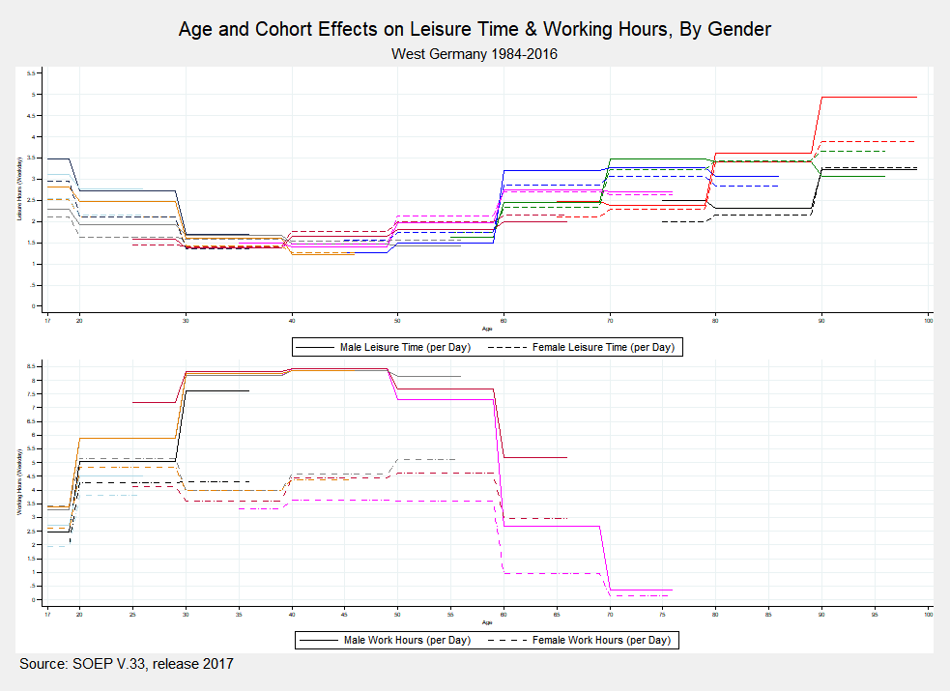

### **Appendix 2.**

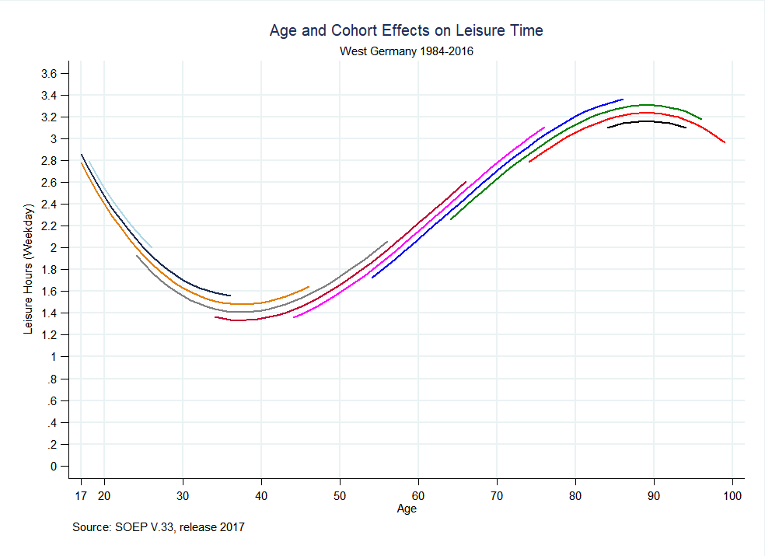

### **Appendix 3.**

